ANCIENT GREEK SCULPTURE
Possible Functions of Sculpture in the Ancient World:
1: icon / image idol - worship or veneration
2: monument propaganda - inspire or to be revered
3: historical record narrative e- record event for the future
4: decorative element embellishment - to architecture
5: theoretical investigation canon - an intellectual construct of an aesthetic ideal

Possibilities for Analysis:

Stance / Presentation
Anatomical Detail / Correctness
Movement / Gesture
Facial expression
Negative space
Organic / Geometric Form
Technique / Material

STYLISTIC ANALYSIS/Formal qualities: (Form, Proportion, Mass, Volume, Space, Texture, Balance, Repetition, Rhythm)

Methods of Creating Sculpture:
1: Subtractive Method: the form is created by removing (as in carving) from a block or mass.
2: Additive Method: the form is built up by modeling in clay, constructing (joining) materials
3: Casting: Subtractive or additive methods of creating sculpture can then be cast in another material - such as bronze - by taking molds (a three dimensional imprint) from the forms.

Types of Sculpture:
1: Freestanding sculpture in the round
2: Relief Sculpture sculptural forms which project from a surface or background
Types of Relief Sculpture:
- Low Relief: forms project only slightly from the background. Also called bas relief.
- High Relief: form project significantly from the background.
- Negative Relief: images are incised into a flat surface - emphasis on contours and outlines rather than forms

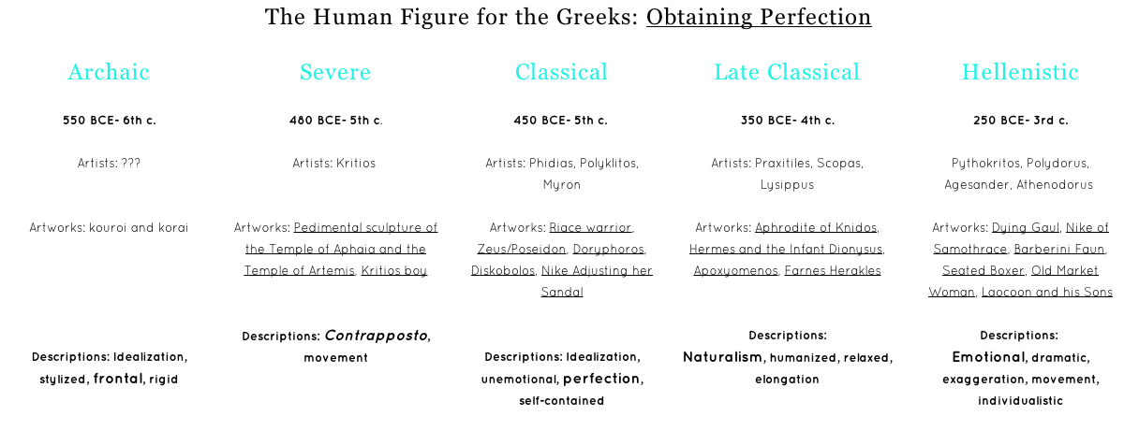
ANCIENT GREEK ARCHITECTURE

